

Updating WordPress and Plugins

User Guide

*Recommended to be completed the first of every month*

Prepared by The Woodland Rangers

UGA MBT Capstone Project

April 28, 2018

The purpose of this document is how to perform routine maintenance to keep <https://www.friendsofsmithgallwoods.org> as secure as possible. We recommend the following procedures be completed **once a month** to keep the security of the website up to date. Plugins are tools that help the site run efficiently. These too can be vulnerable to hacking so keeping them up to date should be a priority of any website.

# **Updating WordPress and Plugins**

1. Log in at <https://www.friendsofsmithgallwoods.org/wp-admin/>
2. If a WordPress update is available, you will be prompted next to dashboard like in the photo below (note: there will not always be an update available)

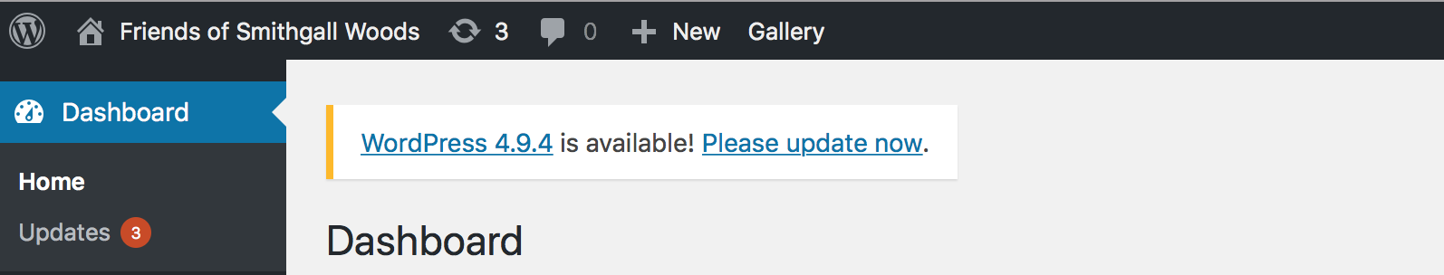

1. Click on “Please update now”.
2. A new screen will appear:

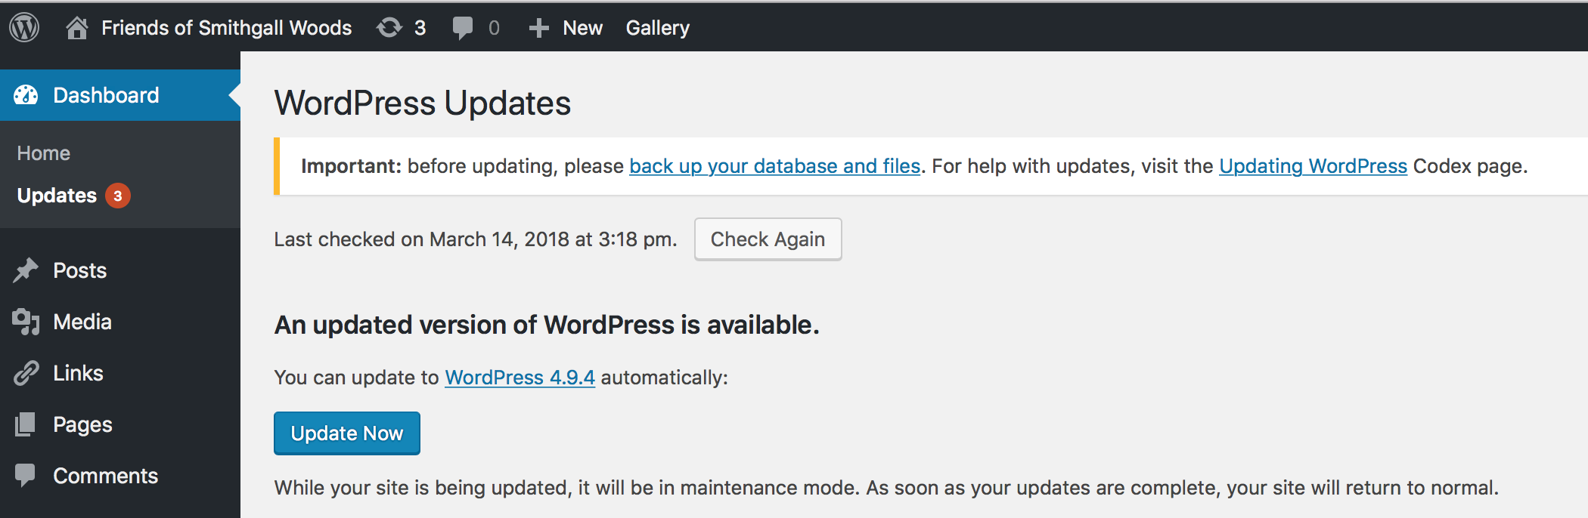

1. Click on “Update Now” box.
2. This will bring your WordPress up to date.
3. Next we will want to check for plugin updates. If there are plugins that need to be updated, there will be a number next to “Updates”.

1. Click on “Updates”.

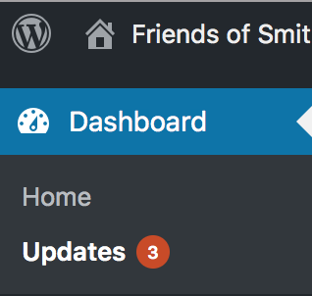

1. On this page, click on the box next to “Select All”. This selects all plugins for which updates are available.

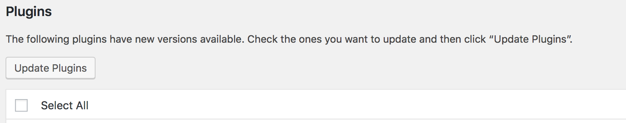

1. Then click “Update Plugins”.
2. The webpage will refresh and give the status of the plugins being updated. Once all plugins have been “updated successfully,” WordPress and all plugins are up-to-date.